Name _____________________________________________________________________________
-ap, -ed, in word family
Directions: Choose a can. Color it appropriately. Write the word for the picture that is on the can. All words will end with –ap, -ed, or -in.

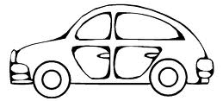
- __________________________ 4. ___________________________

- ___________________________ 5. ___________________________

- ___________________________ 6. ___________________________

Choose 1 –ap, -ed, in word and write a sentence for each.
__________________________________________________________________________________
__________________________________________________________________________________

